**Department of Information Technology**

**Academic Year: 2022-23 Name of Student:**

**Semester: VI Student ID:**

**Class / Branch / Div: TE- IT A/B Roll No.**

**Subject: MAD & PWA Lab Date of Submission:**

**Name of Instructor:**

**Experiment No.:1**

**Aim:** To install and configure Flutter Environment.

**Theory:**

# Flutter Installation

## Install Git

**Step 1:** To download Git.

**Step 2:** Run the **.exe** file to complete the installation. During installation, make sure that you have selected the recommended option.

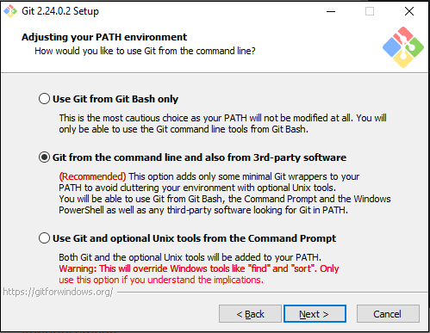

## Install the Flutter SDK

**Step 1:** Download the installation bundle of the Flutter Software Development Kit for windows. To download Flutter SDK, Go to its official [website](https://flutter.dev/" \t "_blank)

click on **Get started** button, you will get the following screen.

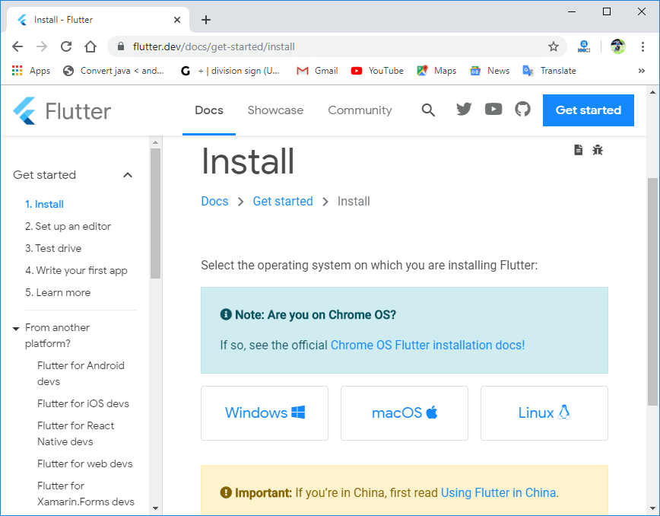

**Step 2:** Next, to download the latest Flutter SDK, click on the Windows **icon**. Here, you will find the download link for [SDK](https://flutter.dev/docs/get-started/install/windows" \t "_blank)

**Step 3:** When your download is complete, extract the **zip** file and place it in the desired installation folder or location, for example, D: /Flutter

**Step 4:** To run the Flutter command in regular windows console, you need to update the system path to include the flutter bin directory. The following steps are required to do this:

**Step 4.1:** Go to MyComputer properties -> advanced tab -> environment variables. You will get the following screen.

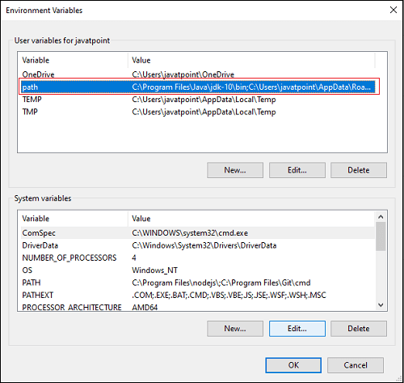

**Step 4.2:** Now, select path -> click on edit. The following screen appears.

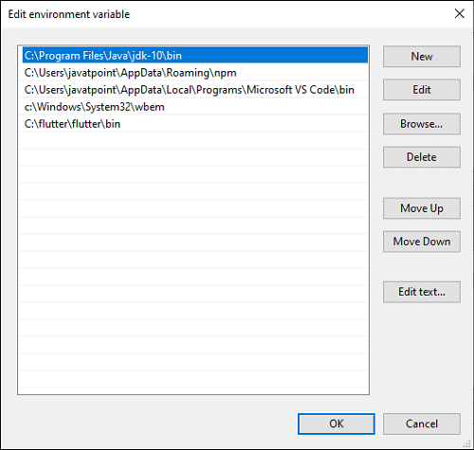

**Step 4.3:** In the above window, click on New->write path of Flutter bin folder in variable value -> ok -> ok -> ok.

**Step 5:** Now, run the $ **flutter doctor** command. This command checks for all the requirements of Flutter app development and displays a report of the status of your Flutter installation.

1. $ flutter doctor

**Step 6:** When you run the above command, it will analyze the system and show its report, as shown in the below image. Here, you will find the details of all missing tools, which required to run Flutter as well as the development tools that are available but not connected with the device.

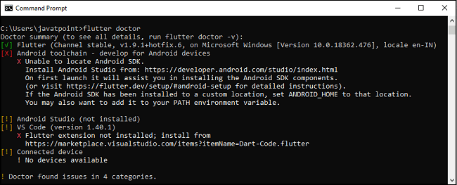

**Step 7:** Install the Android SDK. If the flutter doctor command does not find the Android SDK tool in your system, then you need first to install the Android Studio IDE. To install Android Studio IDE, do the following steps.

**Step 7.1:**Download the latest Android Studio executable or zip file from the [official site](https://developer.android.com/studio/" \l "downloads" \t "_blank)

**Step 7.2:** When the download is complete, open the **.exe** file and run it. You will get the following dialog box.

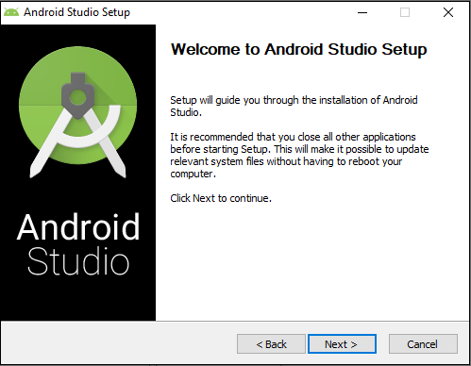

**Step 7.3:** Follow the steps of the installation wizard. Once the installation wizard completes, you will get the following screen.

**Step 7.4:** In the above screen, click Next-> Finish. Once the Finish button is clicked, you need to choose the 'Don't import Settings option’ and click OK. It will start the Android Studio.

#### Note:> Meanwhile, the installation wizard also includes downloading Android SDK components that are required by Flutter for development.

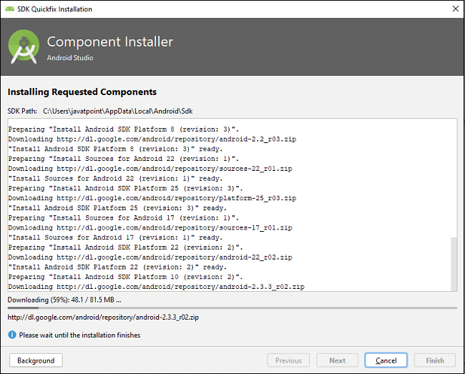

**Step 8:** Next, you need to set up an Android emulator. It is responsible for running and testing the Flutter application.

**Step 8.1:**To set an Android emulator, go to Android Studio > Tools > Android > AVD Manager and select Create Virtual Device. Or, go to Help->Find Action->Type Emulator in the search box. You will get the following screen.

**Step 8.2:** Choose your device definition and click on Next.

**Step 8.3:** Select the system image for the latest Android version and click on Next.

**Step 8.4:** Now, verify the all AVD configuration. If it is correct, click on Finish. The following screen appears.

**Step 8.5:** Last, click on the icon pointed into the red color rectangle. The Android emulator displayed as below screen.

**Step 9:** Now, install Flutter and Dart plugin for building Flutter application in Android Studio. These plugins provide a template to create a Flutter application, give an option to run and debug Flutter application in the Android Studio itself. Do the following steps to install these plugins.

**Step 9.1:** Open the Android Studio and then go to File->Settings->Plugins.

**Step 9.2:** Now, search the Flutter plugin. If found, select Flutter plugin and click install. When you click on install, it will ask you to install Dart plugin as below screen. Click yes to proceed.

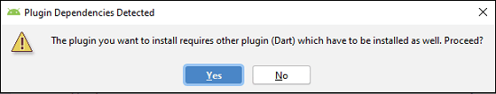

**Step 9.3:** Restart the Android Studio.

# Flutter First Application

In this section, we are going to learn how to create a simple application in Android Studio to understand the basics of the Flutter application. To create Flutter application, do the following steps:

**Step 1:** Open the Android Studio.

**Step 2:** Create the Flutter project. To create a project, go to File-> New->New Flutter Project. The following screen helps to understand it more clearly.

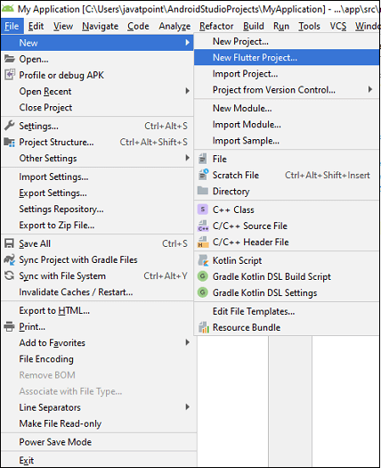

**Step 3:** In the next wizard, you need to choose the Flutter Application. For this, select Flutter Application-> click Next, as shown in the below screen.

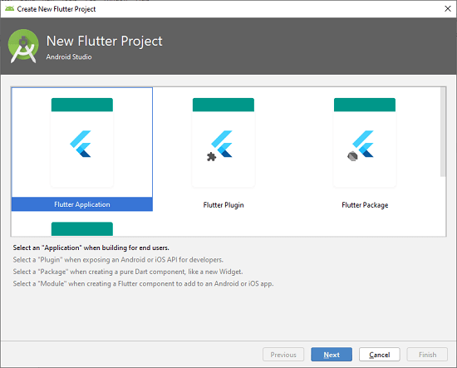

**Step 4:** Next, configure the application details as shown in the below screen and click on the Next button.

**Project Name:** Write your Application Name.

**Flutter SDK Path:** <path\_to\_flutter\_sdk>

**Project Location:** <path\_to\_project\_folder>

**Descriptions:** <A new Flutter hello world application>.

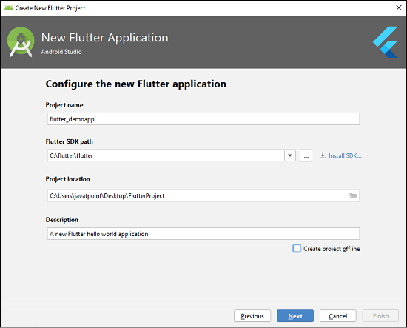

**Step 5:** In the next wizard, you need to set the company domain name and click the Finish button.

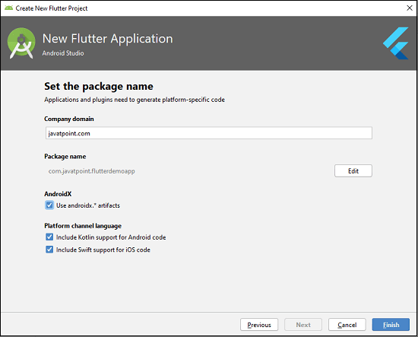

After clicking the Finish button, it will take some time to create a project. When the project is created, you will get a fully working Flutter application with minimal functionality.

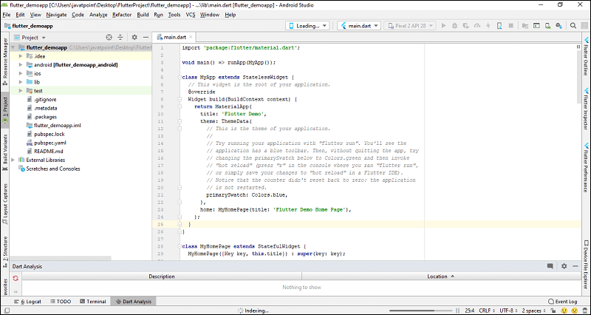

**Step 6:** Now, let us check the structure of the Flutter project application and its purpose. In the below image, you can see the various folders and components of the Flutter application structure, which are going to discuss here.

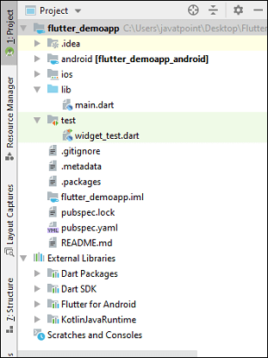

**Step 7:** Open the **main.dart** file and replace the code with the following code snippets.

**import** 'package:flutter/material.dart';

**void** main() => runApp(MyApp());

**class** MyApp **extends** StatelessWidget {

  // This widget is the root of your application.

  @override

  Widget build(BuildContext context) {

**return** MaterialApp(

      title: 'Hello World Flutter Application',

      theme: ThemeData(

        // This is the theme of your application.

        primarySwatch: Colors.blue,

      ),

      home: MyHomePage(title: 'Home page'),

    );

  }

}

**class** MyHomePage **extends** StatelessWidget {

  MyHomePage({Key key, **this**.title}) : **super**(key: key);

  // This widget is the home page of your application.

**final** String title;

  @override

  Widget build(BuildContext context) {

**return** Scaffold(

      appBar: AppBar(

        title: Text(**this**.title),

      ),

      body: Center(

        child: Text('Hello World'),

      ),

    );

  }

}

**Step 9:** Now, run the application. To do this, go to Run->Run main.dart, as shown in the below screen.

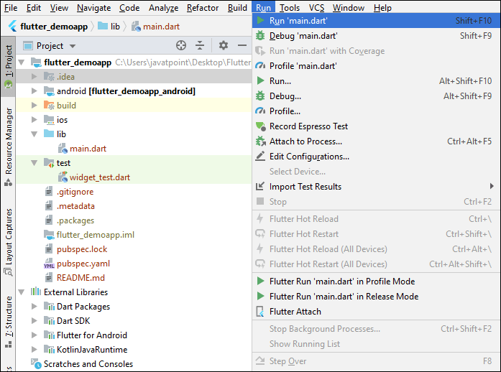

**Step 10:** Finally, you will get the output as below screen.

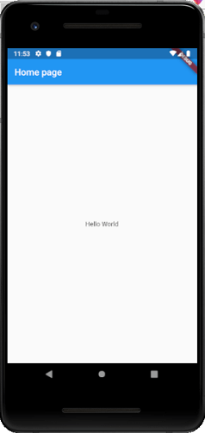

**Conclusion:** In this experiment we have created complete environment to execute flutter applications*.*